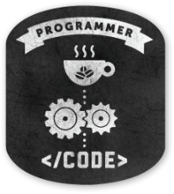**­­­**

Class 7

**Lecture 3**

**Basic Programming**

**(Operators)**

**Programming**

**&**

**Algorithm**

**Lab Objectives:**

* What is Operator?
* Different Types of Operator.
* Different operations in programming.

**What is Operator?**

An operator is a symbol that tells the compiler to perform specific mathematical or logical functions. Such as + , - , /

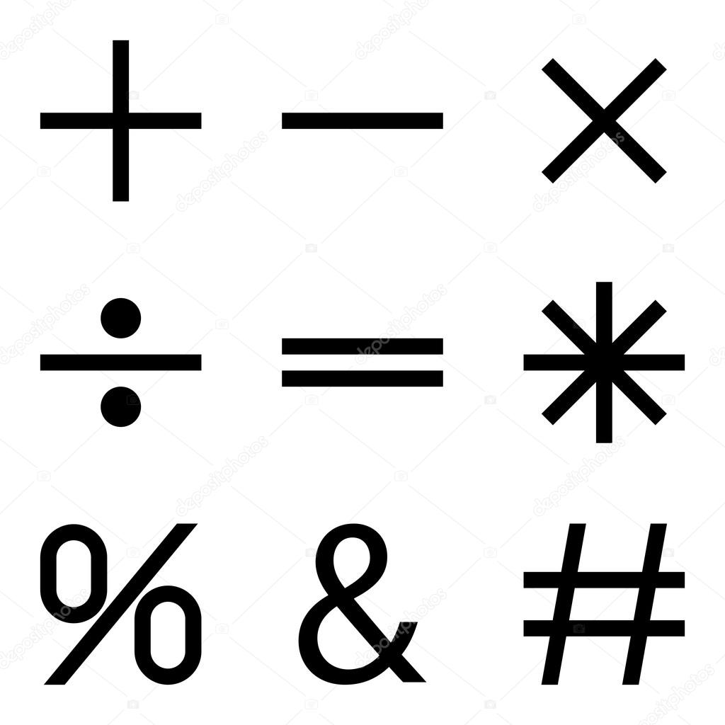

**Types of Operators**

Some type of operators is:

* Arithmetic Operators
* Relational Operators
* Logical Operators
* Bitwise Operators
* Assignment Operators

1. **Arithmetic Operators**

The following table shows all the arithmetic operators.

**Let A = 10 and B = 20**

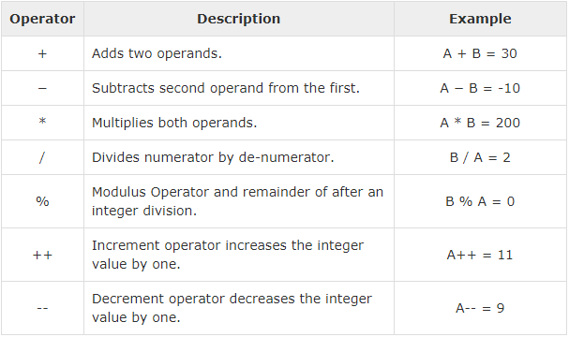

1. **Relational Operators**

The following table shows all the relational operators.

**Let A = 10 and B = 20**

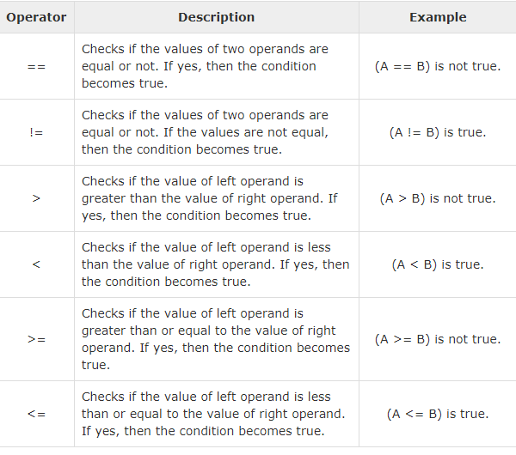

1. **Logical Operators**

The following table shows all the logical operators.

**Let A = 10 and B = 20**

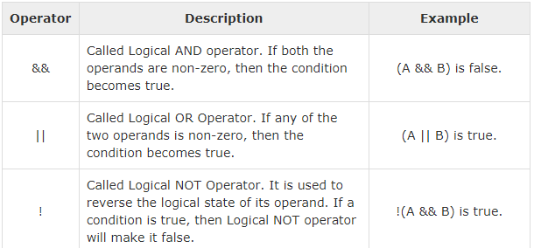

You’ll learn bitwise and assignment operators in higher class